Introduction:

If you are looking to install the game, please see the other document relating to installing on Windows or Mac respectively.

This document will relate how to play the game (such as what buttons are used and what to do on a new screen in the game) and what we have implemented in the current version of the game (4/2017).

Below is the first screen of the game, You can find instructions in the game such as what buttons are used in on a screen. The following sections in this guide will be more thorough. Hit the start game button to begin the game. 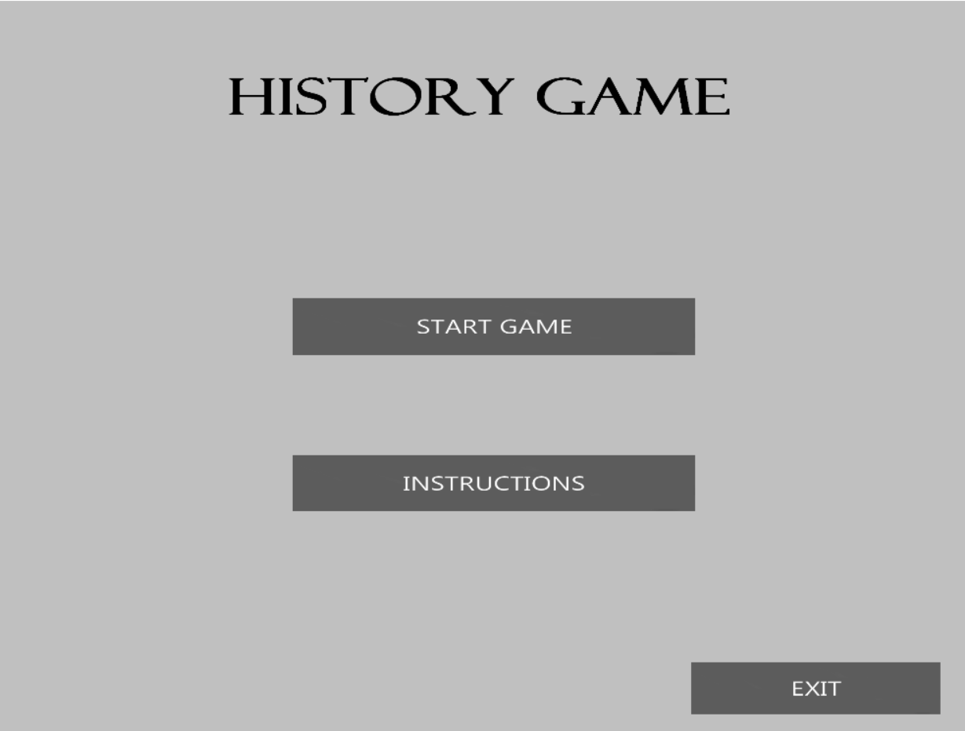

Main Screen:

The below screenshot is the main screen of the game. There are multiple clickable buttons and a green progress bar near the top of the screen. The top right portion of the screen has numbers representing the amount of calories a tribe has under the calories to distribute text. A turn number representing the current turn a player is on, which relates to how many turns survived which is a win condition in this release of the game.

You can advance the phase by clicking the button is the bottom left corner. When you get to the travel phase you can left click on the tribe avatars and the map screen will alert you with what spaces you can move to. By clicking on the moveable spaces the avatar will slide over to them. Right clicking on the land tiles will also display information about them.

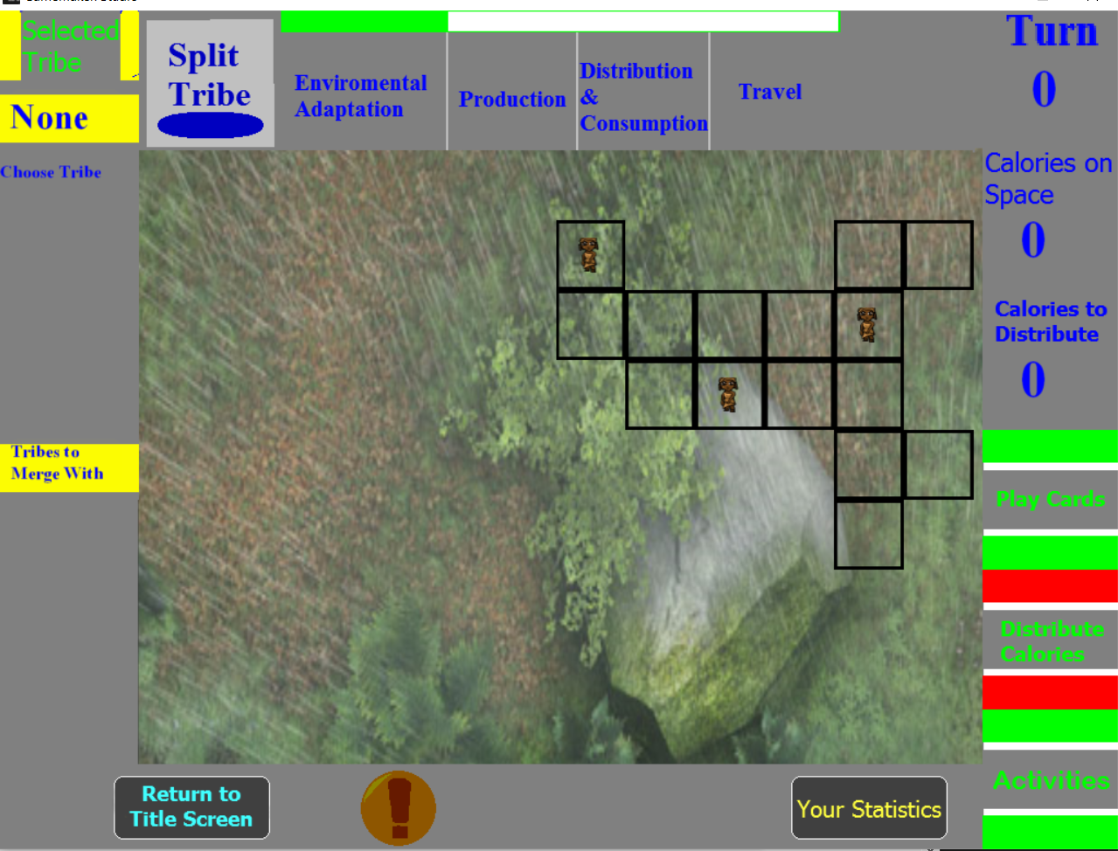

Statistics Screen:

Click on the “Your Statistics” on the map screen to go to the statistics screen. On the left, you can view turn-by-turn changes in the amount of calories, people, and solidarity. To the left, you can see the checklist of your quests. Click on a quest to learn more about it.

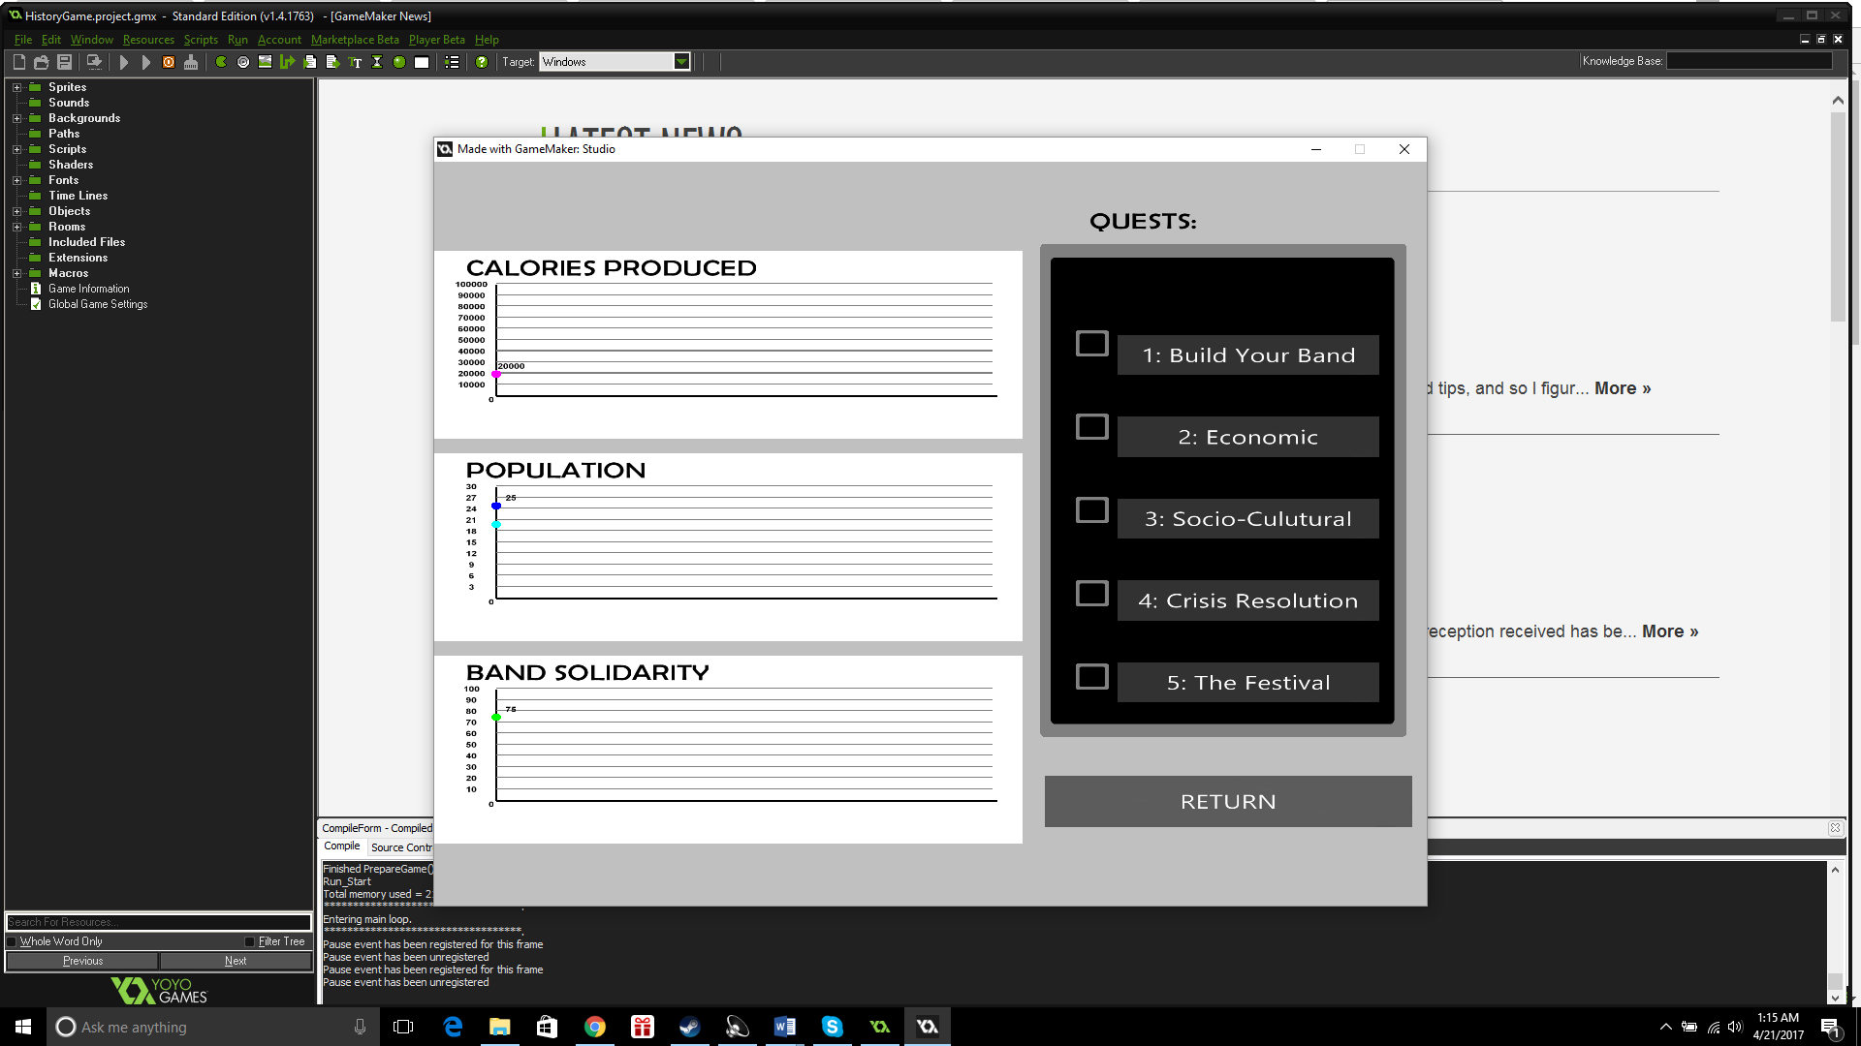

Card Rooms:

In both rooms, one can press the ‘A’ or ‘D’ keys to zoom in or out in both of the card rooms to be able to read what each individual card says. Each arrow key on the keyboard can be used to navigate both rooms in their respective direction as well.

Left click on a card to activate it or left click a button to goto a different screen.

Split/Merge Tribe Screens:

To split a tribe, first select a tribe on the mapscreen by left clicking on a person. Then click on the split tribe button near the top of the mapscreen. Now there should be a room with a wood texture (pictured below) that has the names of the tribe members in the selected group. To create a new group, left click on a person’s name and then click on the swap arrow above every person’s name. There should be a name to the right under the gray box, meaning that person split into another group. Click the return button to return to the mapscreen.

Merging works in the same way except you need to have a two people on the mapscreen to be on the same square. Then the merge button can be clicked to swap members between the two groups in a similar in the above paragraph. If there is no people on one side of the gray boxes, the group will disappear from the mapscreen as the two groups have successfully combined.

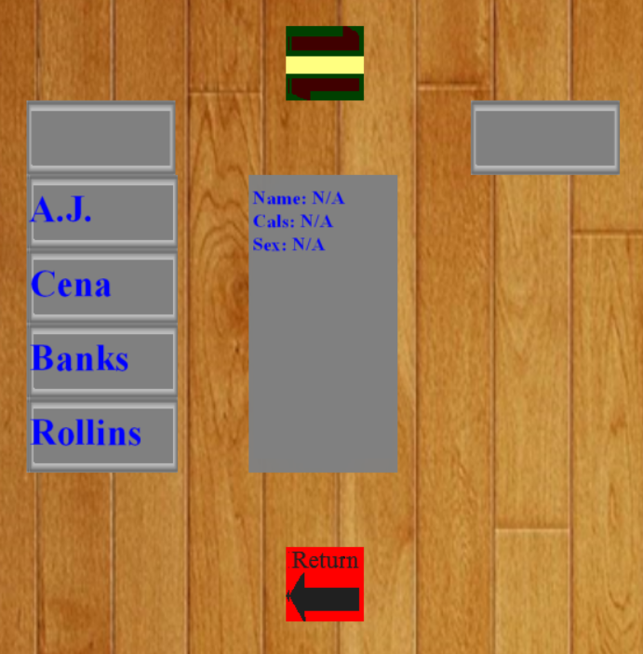

Calorie Distribution:

In the calorie distribution room (pictured below), you will see:

1. All of the tribe members listed with their total calorie count
2. The total amount of calories that the selected tribe has
3. An up and down arrow with which you will decide how many calories to distribute

The up arrow will increment the amount of calories to distribute to a particular tribe member by 2000 calories, the down arrow will decrement by 2000. You cannot distribute more calories than the tribe has or a negative number of calories.

Once you have incremented the calorie count to your liking, you will then simply click on the tribe member’s name to distribute calories to a particular tribe member. You can do this any amount of times, assuming your tribe has enough calories.

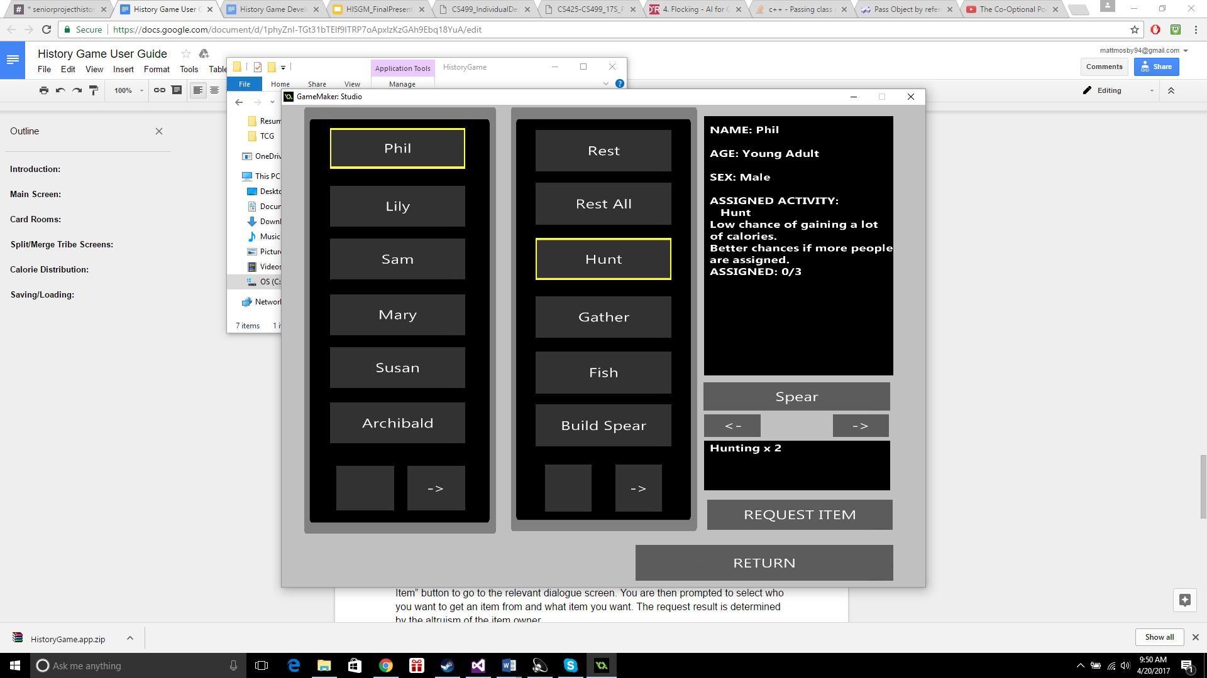

Production:

In the “Activities” room, you will be able to assign tasks to tribe members (such as building equipment and going hunting), equip them with tools, and trade tool with other members. You can simply assign an activity to a tribe member by clicking on the member then clicking on the activity you wish to assign to them. Clicking on a tribe member or an activity will make the relevant information appear in the dialogue box at the far right. You can also pick a tool you wish to equip that tribe member with by clicking the left and right arrows below the far right dialogue box. Relevant information will appear in a dialogue box.

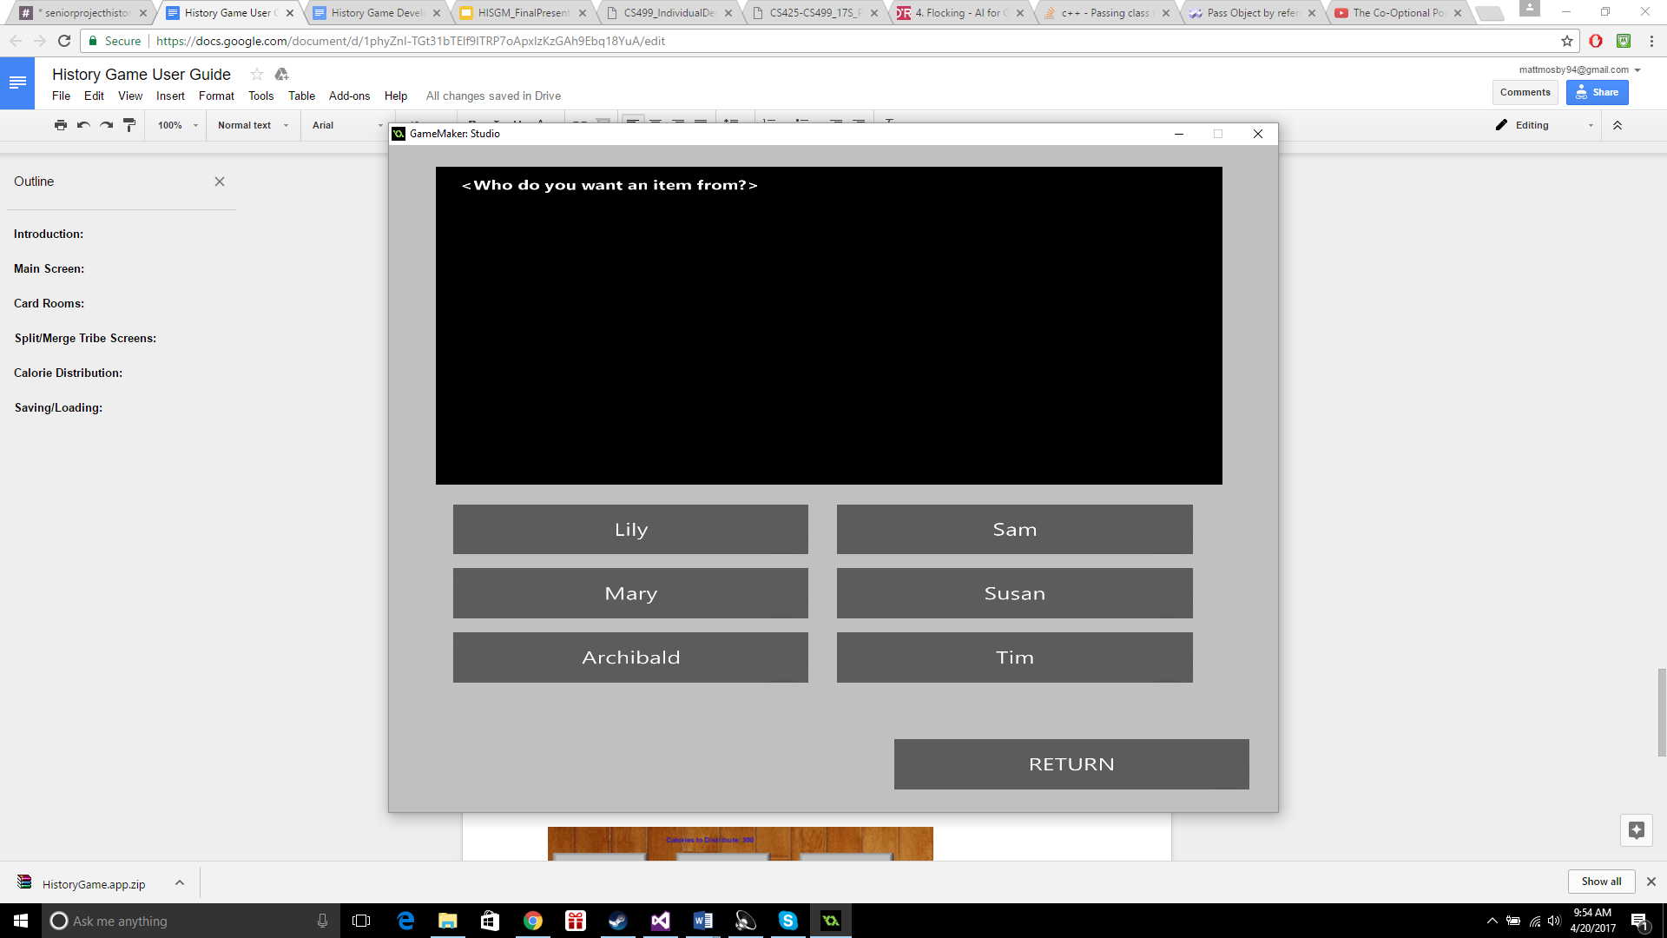

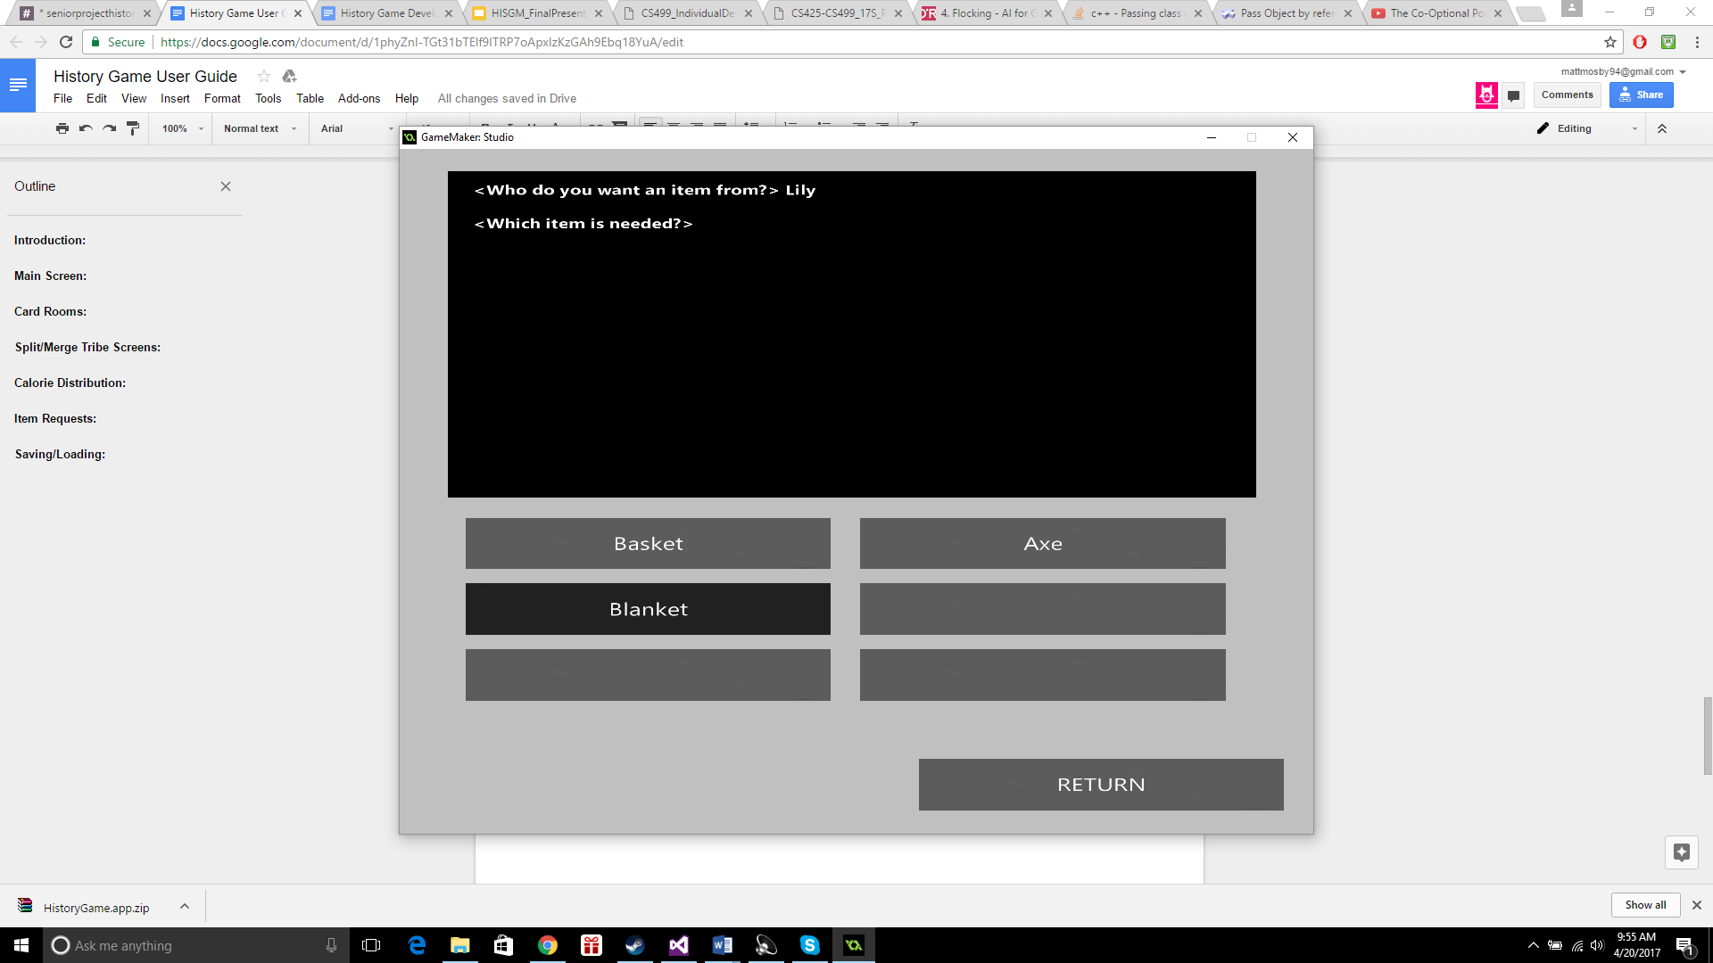

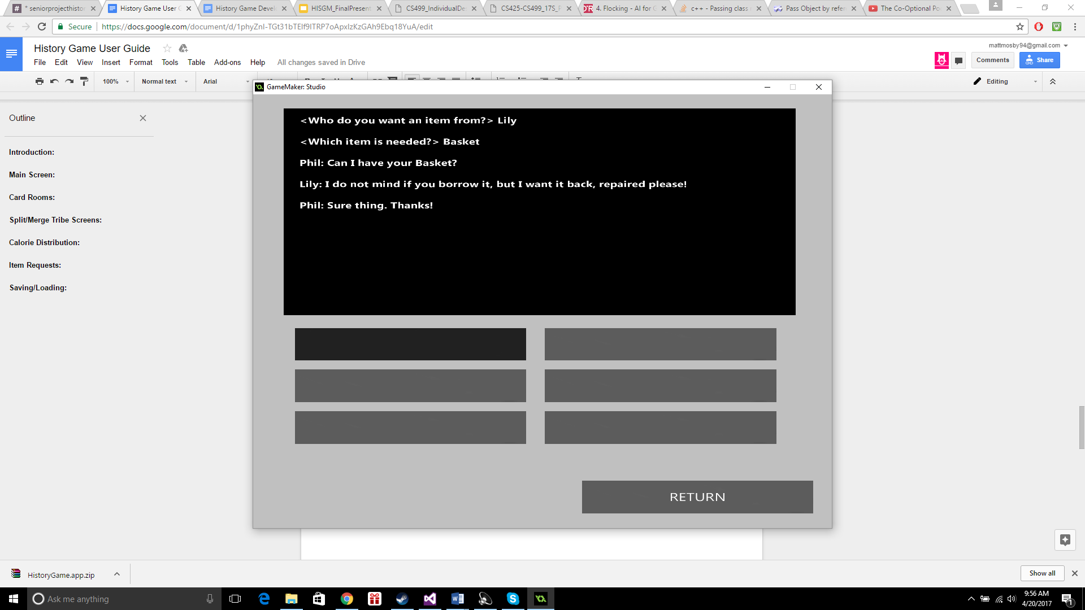

Item Requests:

If you wish to request an item from another tribe member, simply click on the “Request Item” button in the Activities room to go to the relevant dialogue screen. You are then prompted to select who you want to get an item from and what item you want. The request result is determined by the altruism of the item owner.

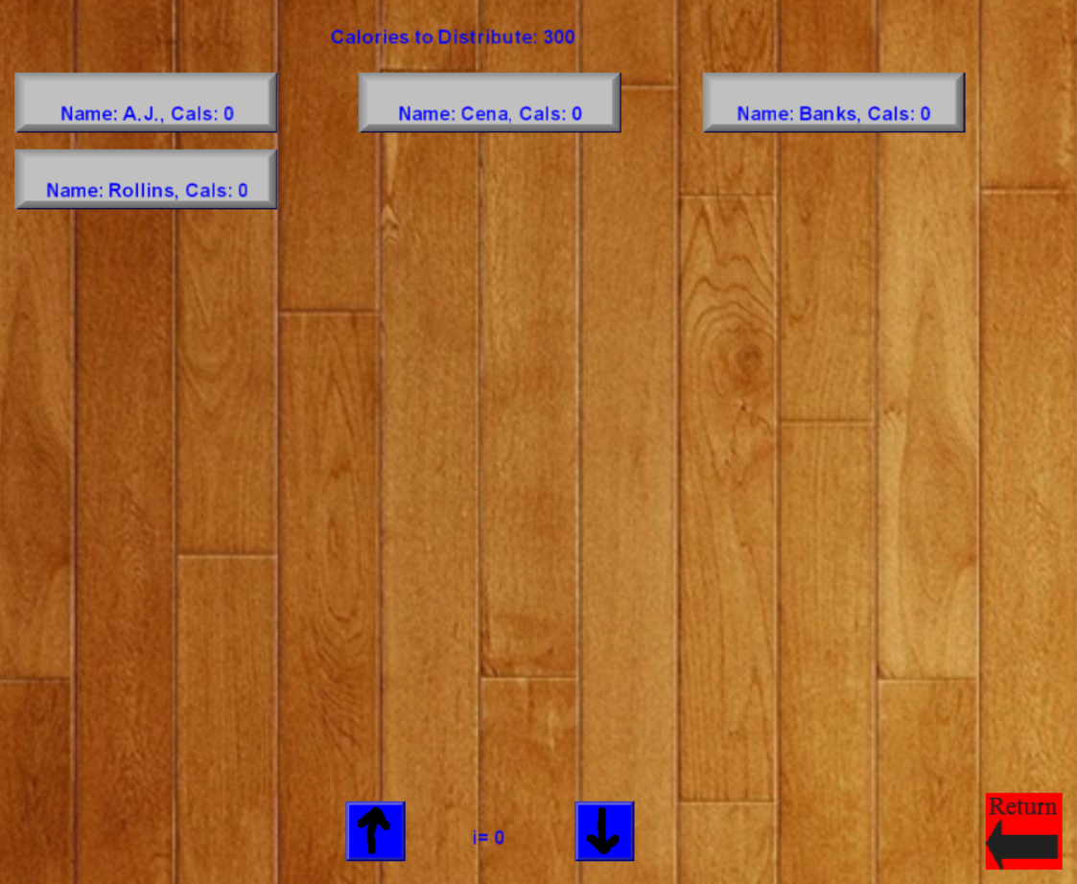

Saving/Loading:

To save a game, you will have to be on the main map screen (mentioned above). Once on the main map screen, you will simply press the ‘S’ key. After you press ‘S’, you will be prompted to save the game with a user-selected title. Be sure to note **where** **you save the game** and **what you name your save**. If you forget either of these things, you may not be able to recover a saved game on a later playthrough.

*To load a game, again you must be on the main map screen. Once on the main map screen, you will simply press the ‘L’ key. After you press ‘L’, you will be prompted to load a game. This is where you will use the file location and/or the save name that you specified when you saved the game initially. After you locate your file, simply select it and the game will load from your previous save.

*To load a game you will have to first start a game because the only loading functionality is on the main map screen.